Programmer’s Document

Client: Charles Sturt University – Finance Department

Project: Employee Payroll Management System

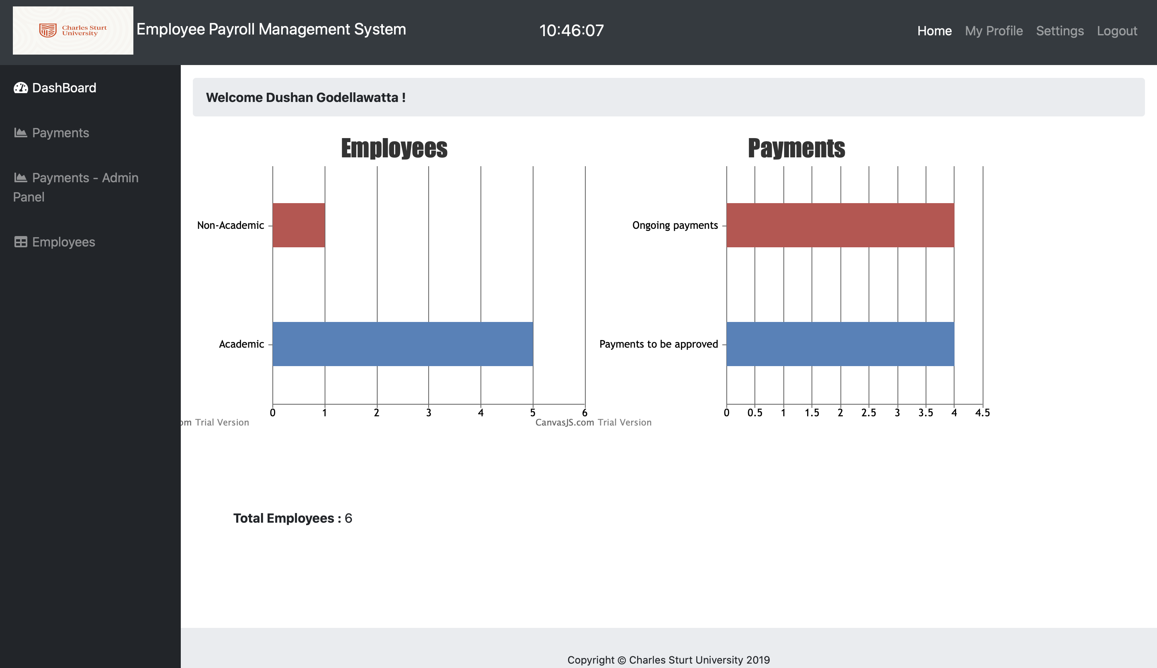

Table of Content

Revision History 5

Introduction 6

Business Objective/AIM 7

SYStem Architecture 7

Roles and Responsibilities 8

Design – SOURCE CODE 8

Login User 8

Login Flow 8

Update My Profile 9

Update My Profile Flow 9

Payments – Select Employee ID 10

Payments – Add Payment 12

Payments – Update Payment 13

Payments – Send for approval 14

Payments – Search Payment (By emp ID) 16

Payments Admin Panel - Pay 17

Payments Admin Panel - Amend 18

Employee – Add Employee 19

20

Employee – Edit Employee 20

Employee – Delete Employee 21

Settings –> User Accounts - Add User 23

Settings –> User Accounts - Edit User 24

Settings –> User Accounts - Delete User 25

Settings -> Staff Info & Rates 26

UML Diagrams 30

Use Case Diagram 30

Activity Diagram 31

# Revision History

| Version | Date | Author | Change |
| --- | --- | --- | --- |
| 1.0 | 2020/05/26 | Dushan |  |
|  |  |  |  |
|  |  |  |  |

# Introduction

This System Design Document has been created to outline the proposed system for Charles Sturt University - Finance Department and details the technical design for Employee Payroll Management System. It is intended to provide technical resources with an explanation of the design and architecture, while providing recommendations on how to implement. By designing, testing and deploying the EPMS, Charles Sturt University will improve its capabilities in keeping track of employee, payment records and calculating salary. This document and the technical specifications listed herein comply with all Charles Sturt University standards and infrastructures.

This document provides project planning information such as source code, database function, etc.

|  |
| --- |
|  |
| * Business Objectives * System Architecture * Design documentation with UML diagrams * Source Code * Database functions |

# Business Objective/AIM

Employee Payroll Management System is developed as a requirement for the Charles Sturt university finance department to migrate their manual employee storing and payment system to an automate system. System is targeted for department accountants and managers(administrators).

# SYStem Architecture

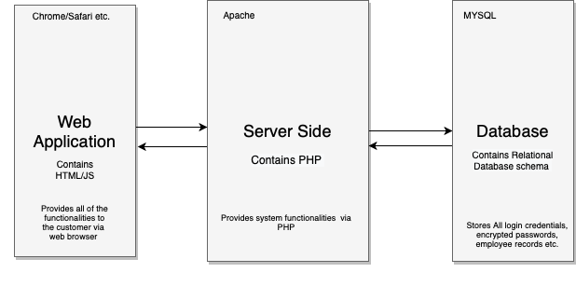

Architecture achieved Goals

* System holds employee and payment information
* System security is enhanced with encrypted passwords.
* System runs in every web browser.
* System runs faster with implementation of some validation techniques on client side.

Decision/Constraints and justifications

* Three tier architecture is used.
* Single database use.
* JavaScript and php used to validate information.

## Roles and Responsibilities

The following table defines the EPMS System Design roles and responsibilities. This matrix also serves as the list of points of contact for issues and concerns relating to the EPMS System Design.

|  |  |  |  |
| --- | --- | --- | --- |
| Name | Role | Phone | Email |
| Dushan | Project Manager, Software Developer | 0450739793 | dushan.gayathra@yahoo.com |
| Kamal | Software Developer | 0431888631 | sulthankamalteja@yahoo.com |

# Design – SOURCE CODE

## Login User

Login is done with interaction of database; user id and password Is used to identify user. Password is encrypted with md5 encryption decryption technique which is implemented on server side.

When user inputs value, redirects to following file,

On Login button click -> Function -> login.php

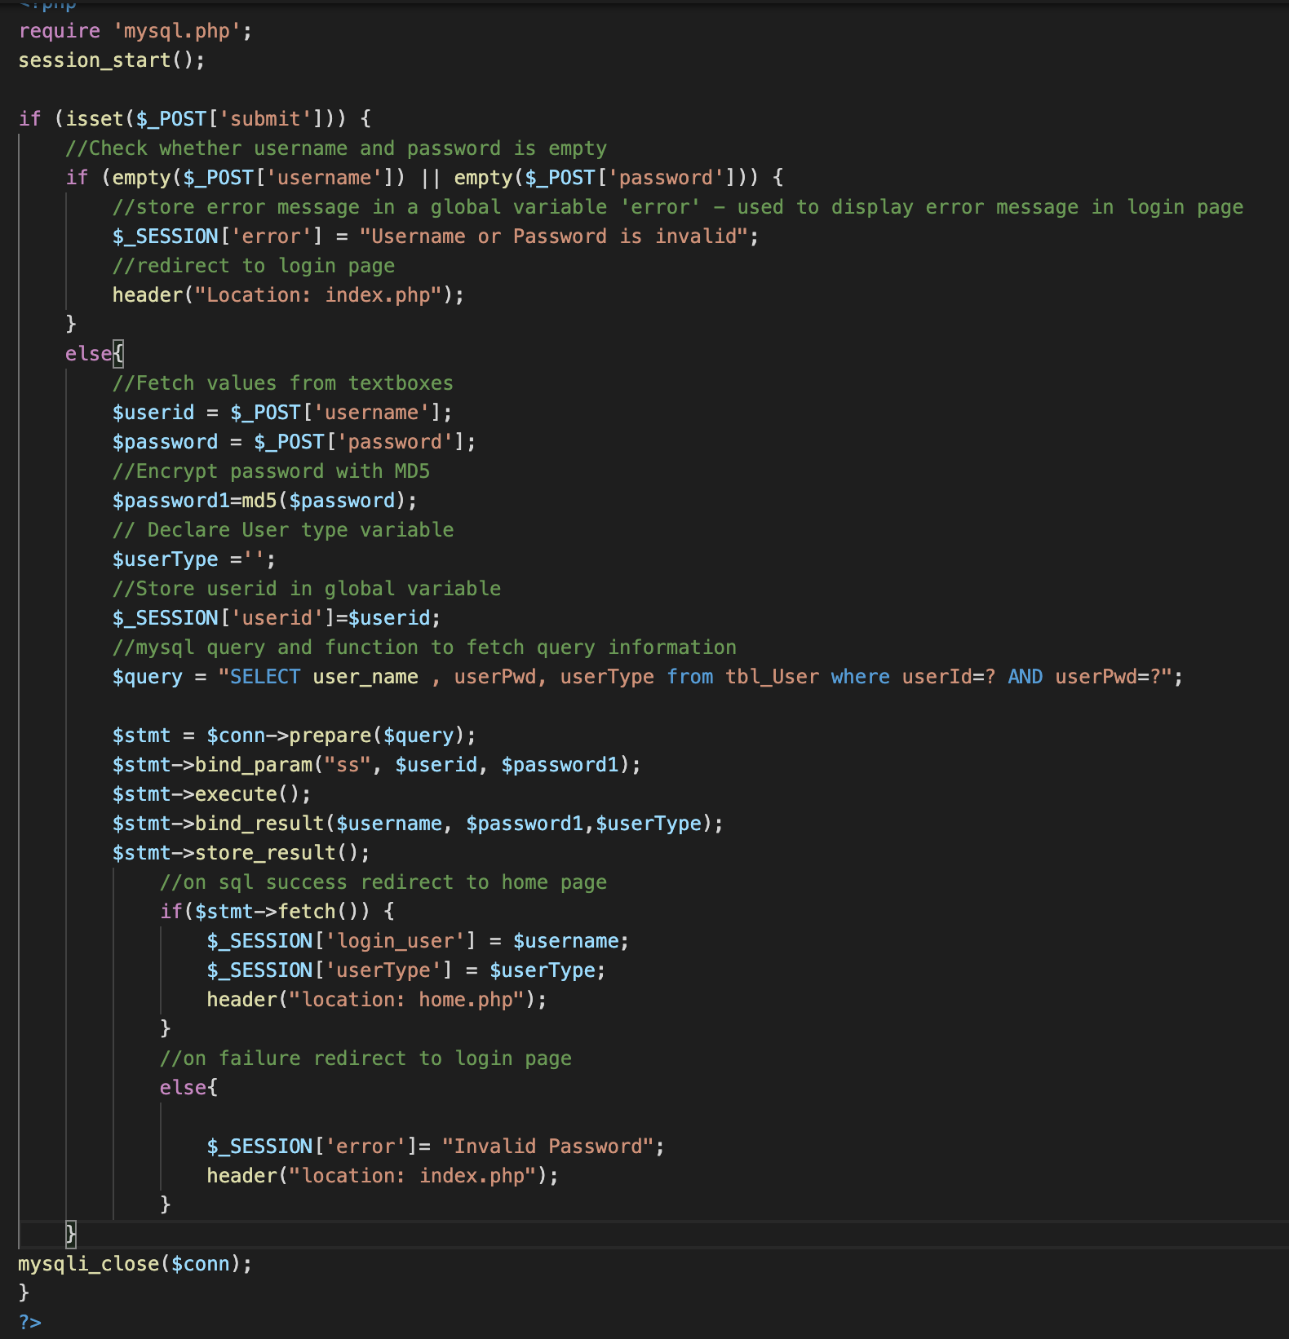

## Update My Profile

Update my profile is done with interaction of database. User can update their name & Password. Password is encrypted on updating method, implemented on server side. On update, user is asked to logout and login again to make changes.

On **My Profile** Navbar link click -> Function -> myprofile.php

After myprofile.php page loads, ‘update profile’ button click function is described in above screenshots

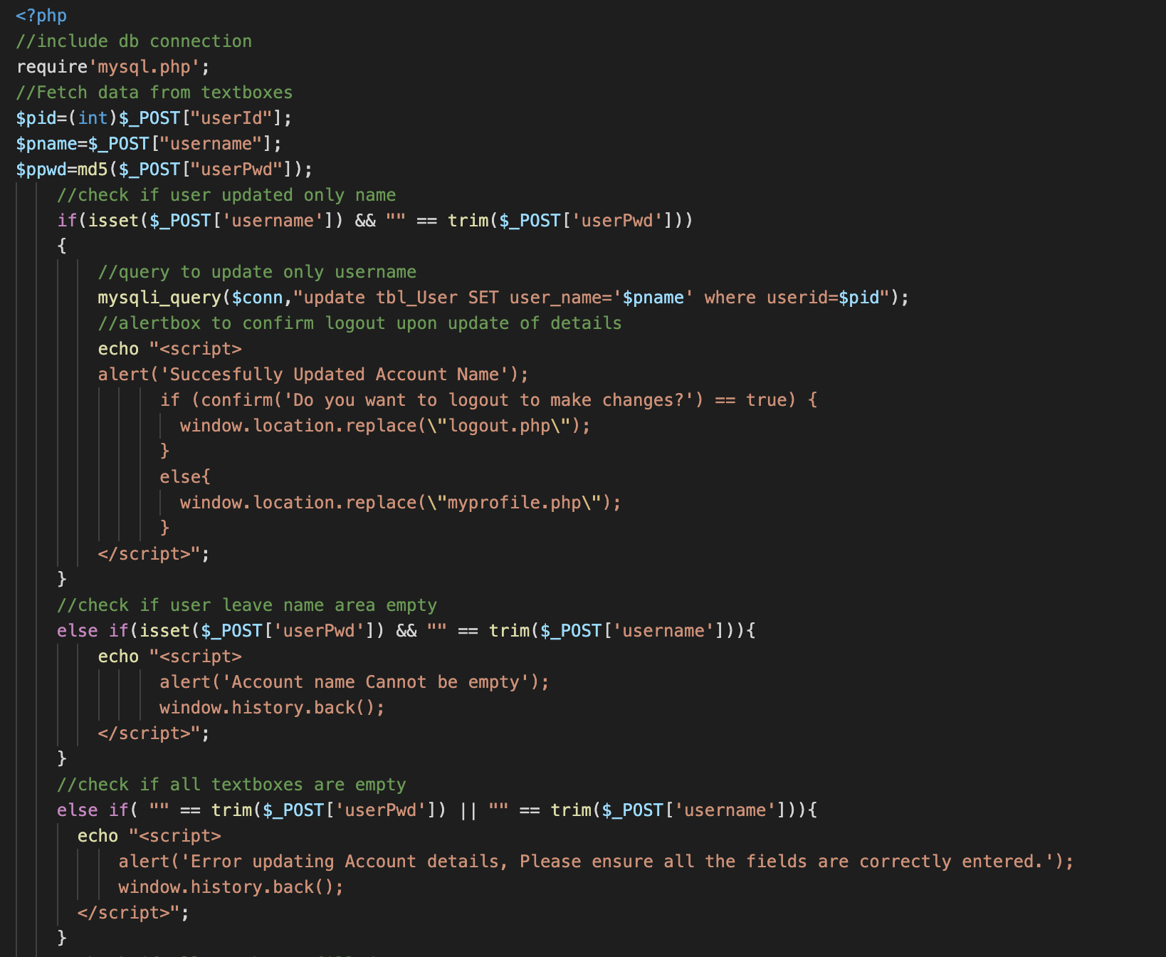

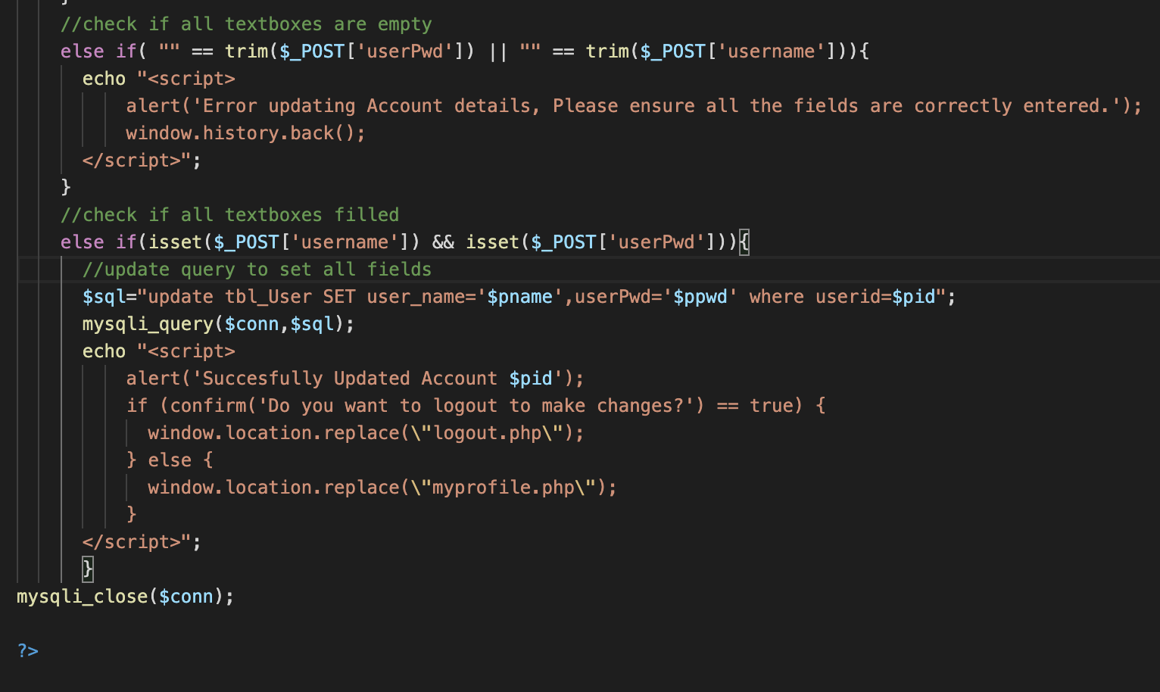

## Payments – Select Employee ID

Note - All Employee IDs will load into the combo box when page loads.

On ID selection, JavaScript will load, and selected employee id pass as a parameter using **GET** method.

On html page load -> Function -> payments.php

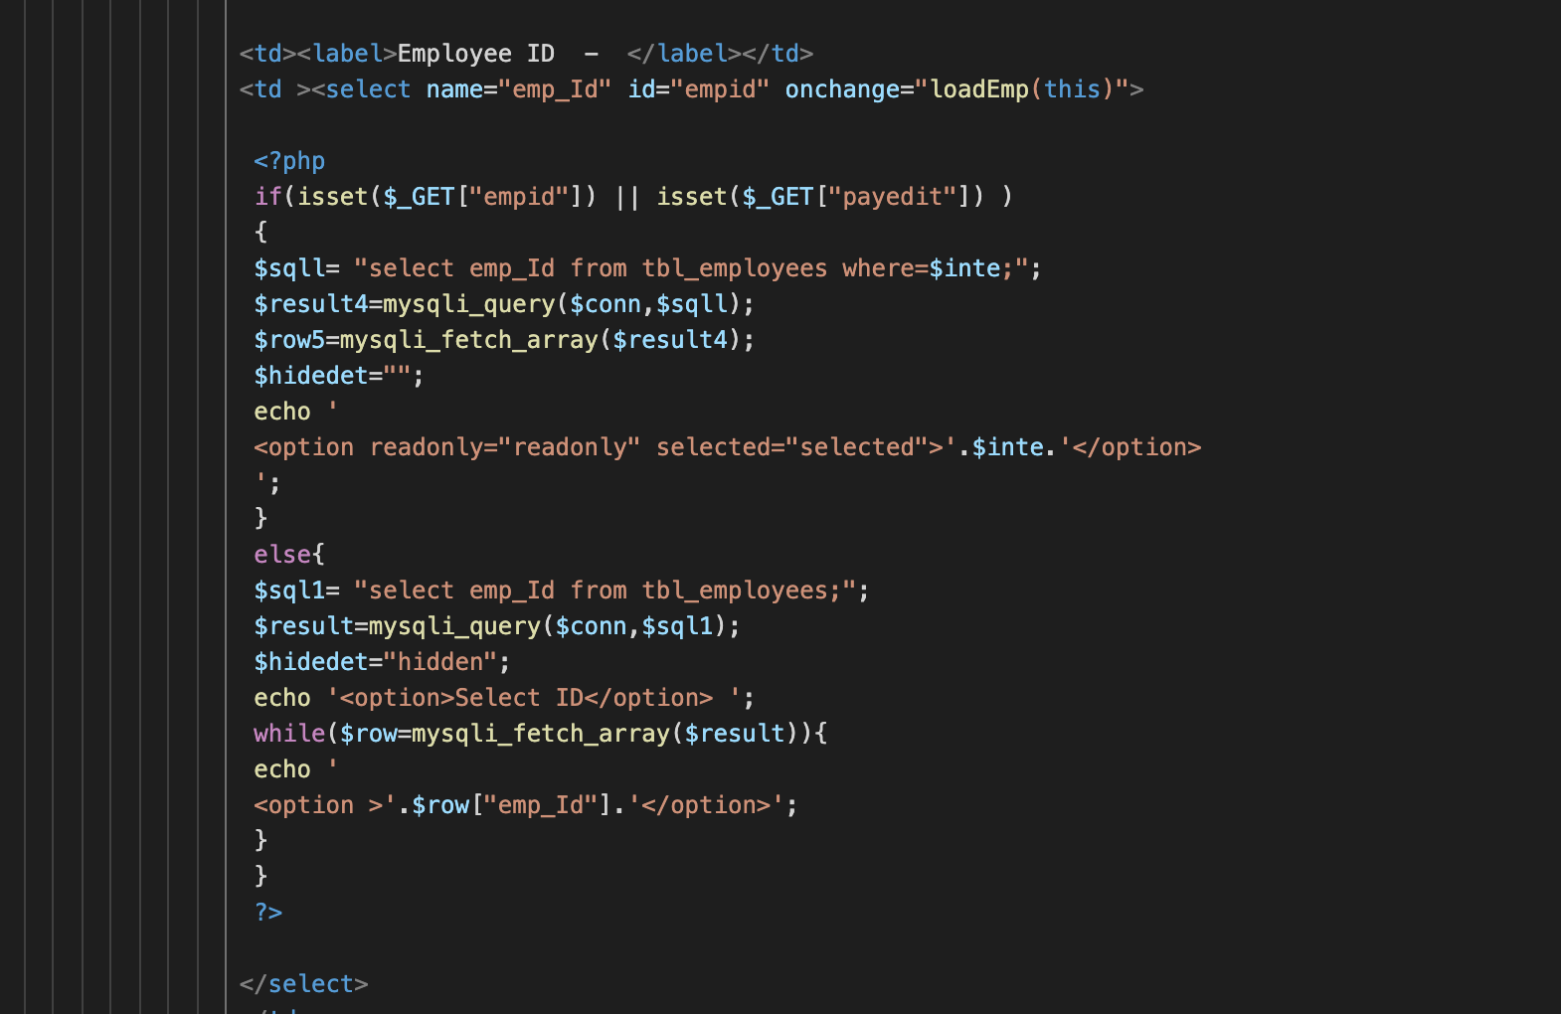

On select combo box -> Function -> Formulas.js (JS to load combo box)

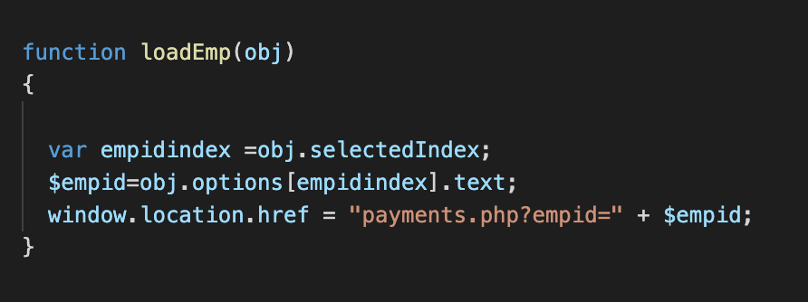

## Payments – Add Payment

On Add Payment button click -> Function -> addPay.php

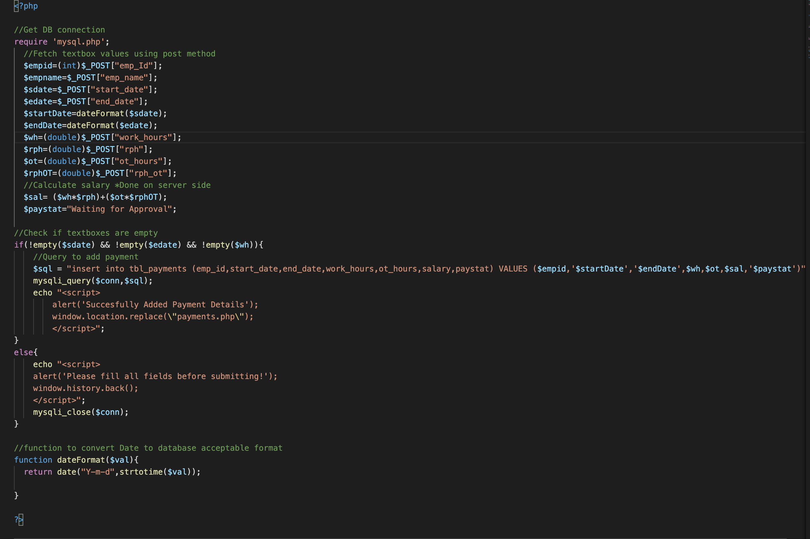

## Payments – Update Payment

On Edit button click -> Function -> updateGET.php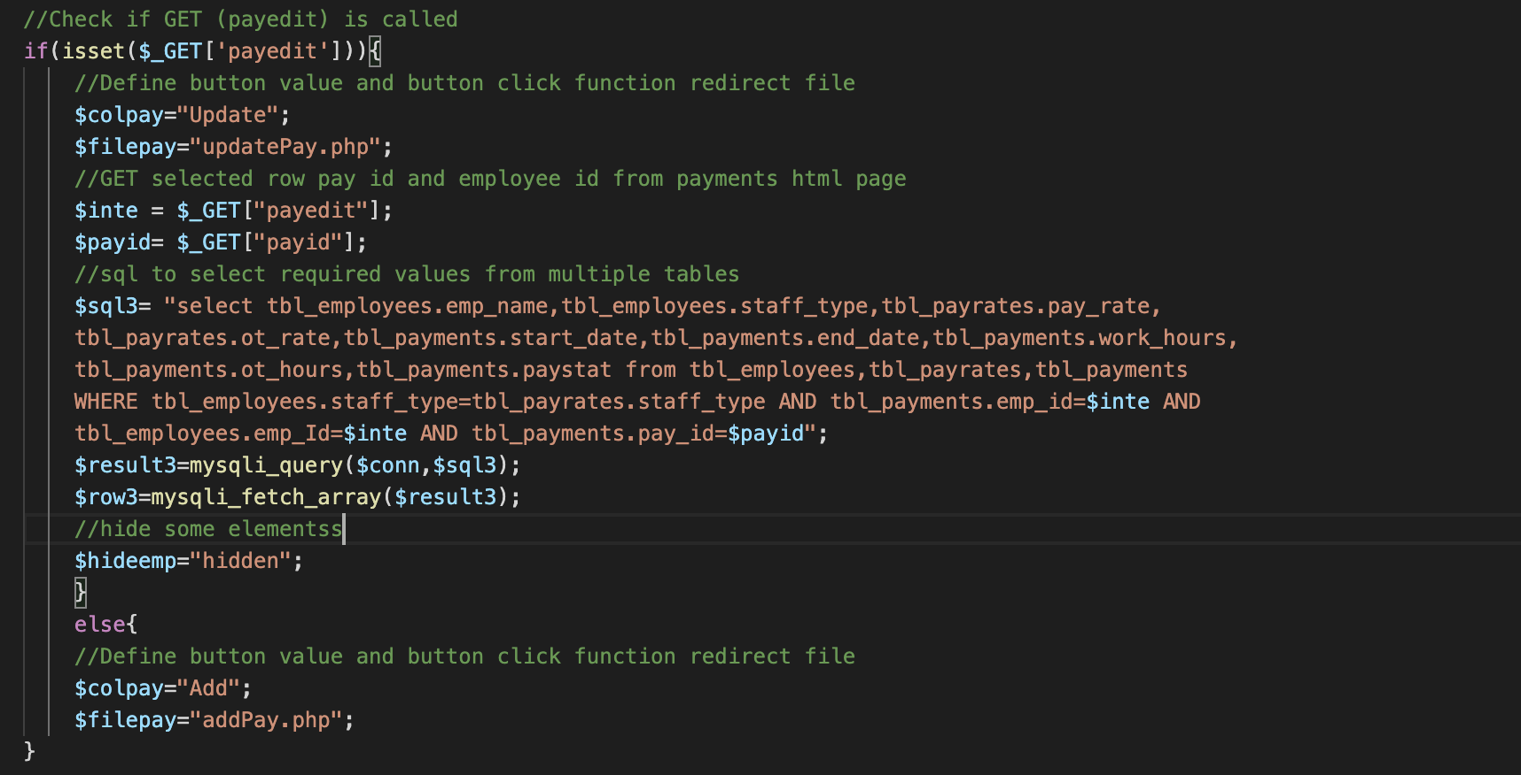

Get method is used to pass payment id as ‘payid’ and employee id as ‘payedit’ to server.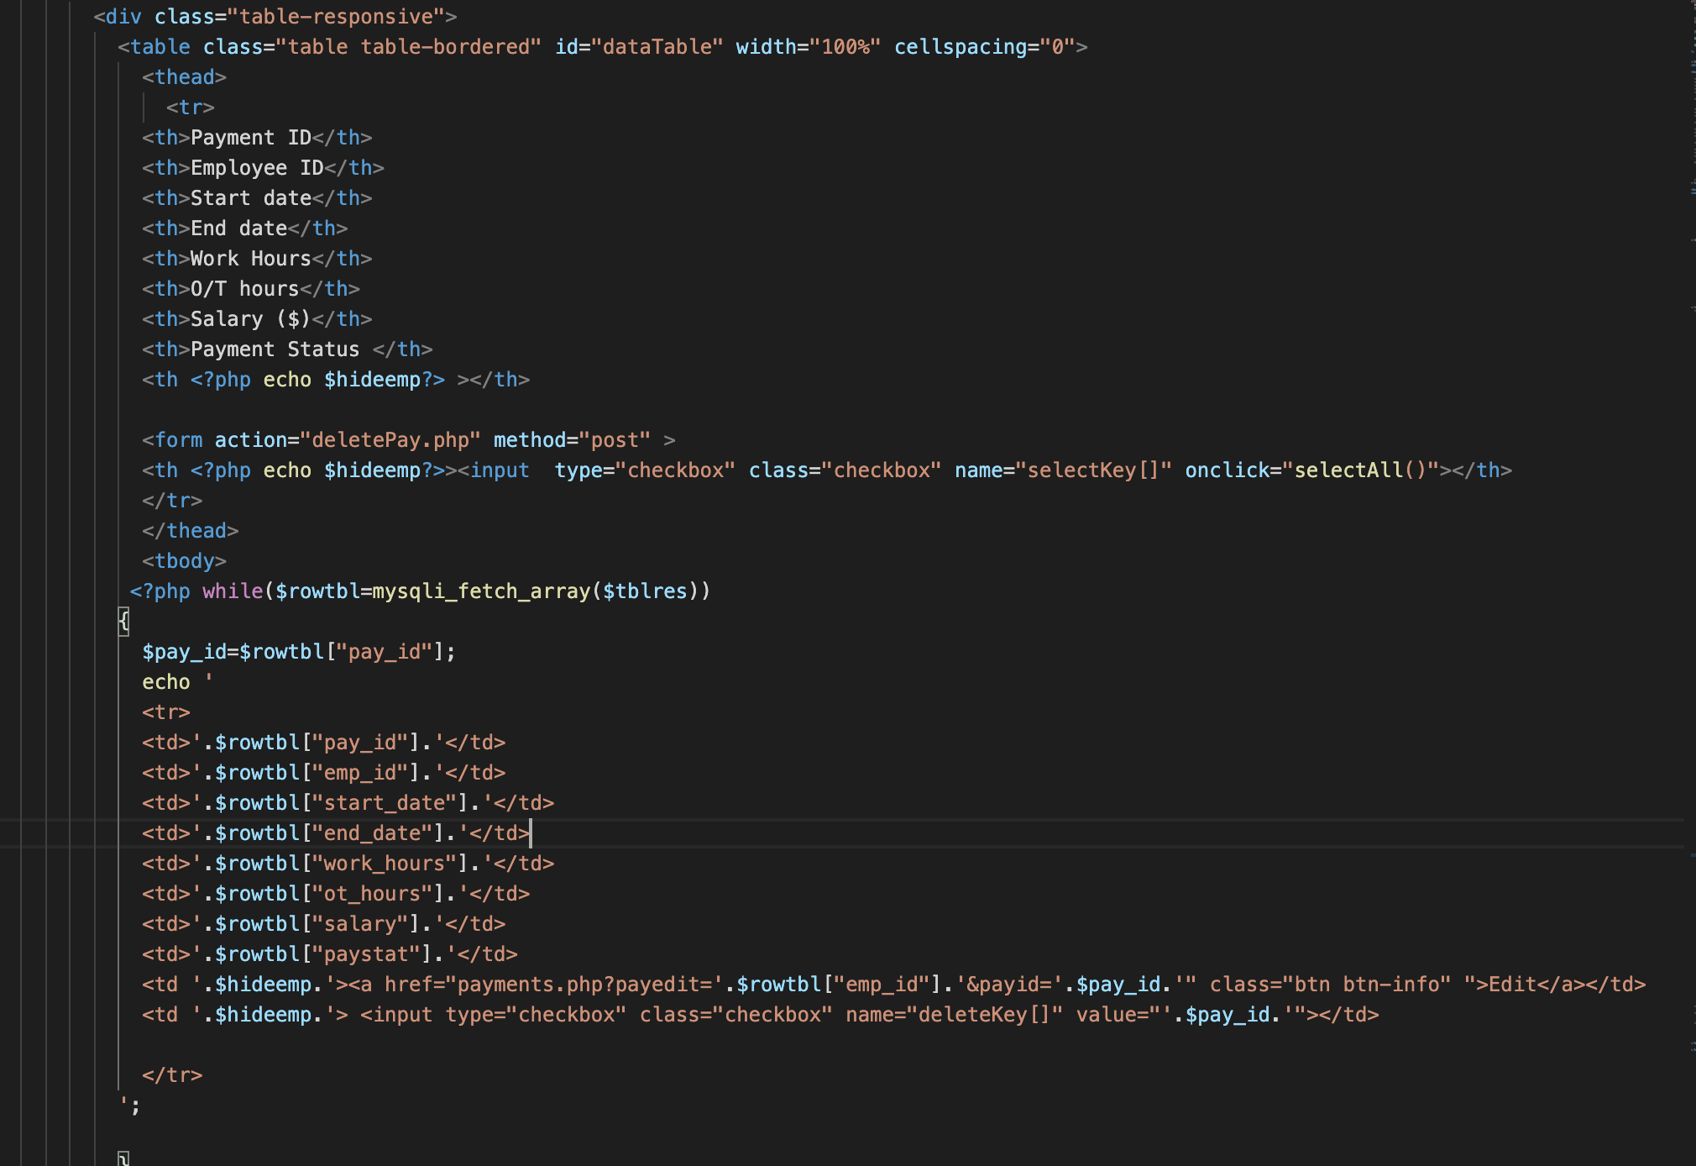

## Payments – Send for approval

On send for approval button click -> Function -> updatePay.php

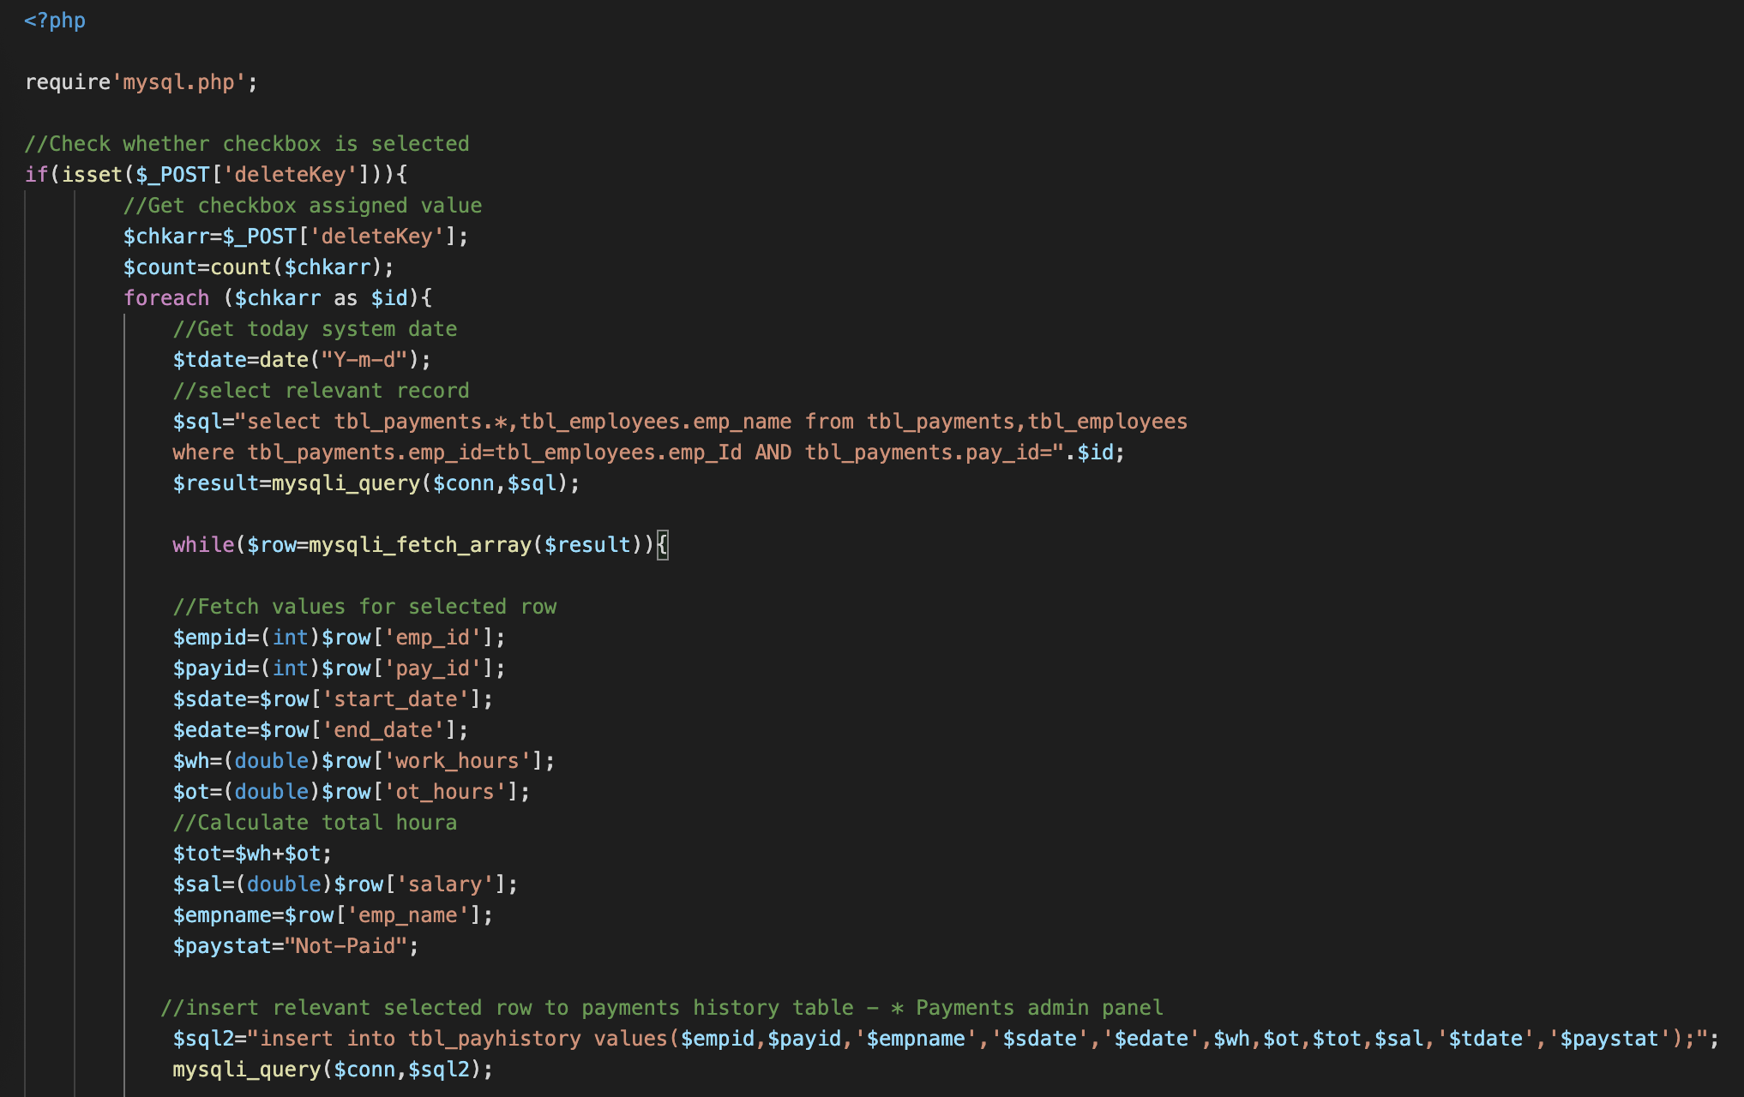

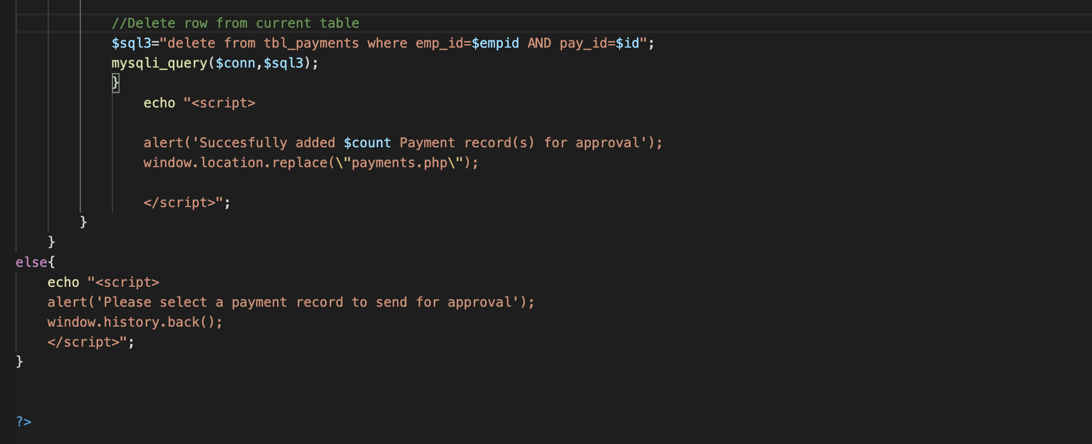

## Payments – Search Payment (By emp ID)



On search text using textbox -> Function -> search(x,x) on payhistory.php

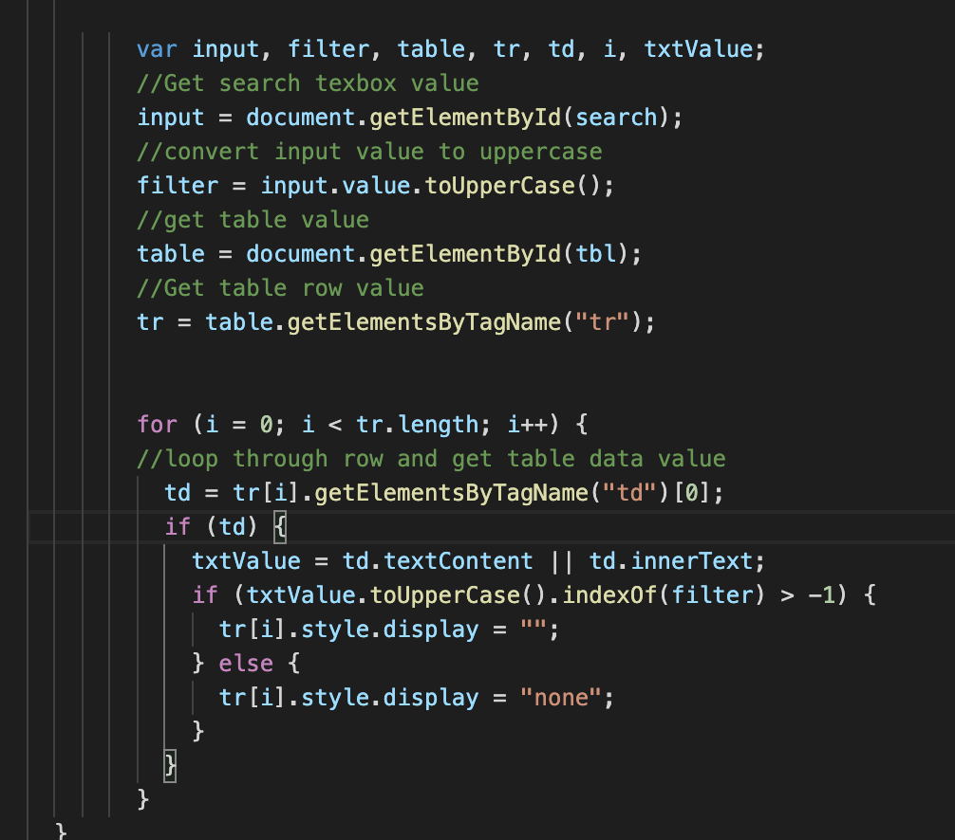

## 

## Payments Admin Panel - Pay

On pay button click -> Function -> pay.php

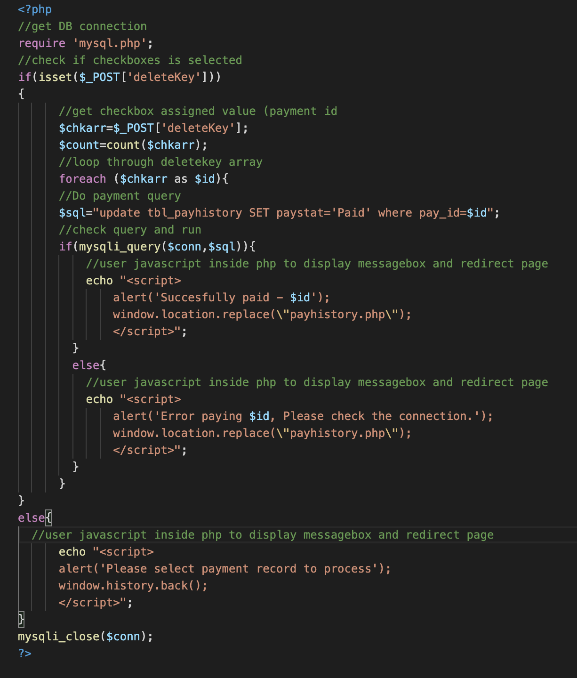

## Payments Admin Panel - Amend

On Amend button click -> Function -> amendPay.php

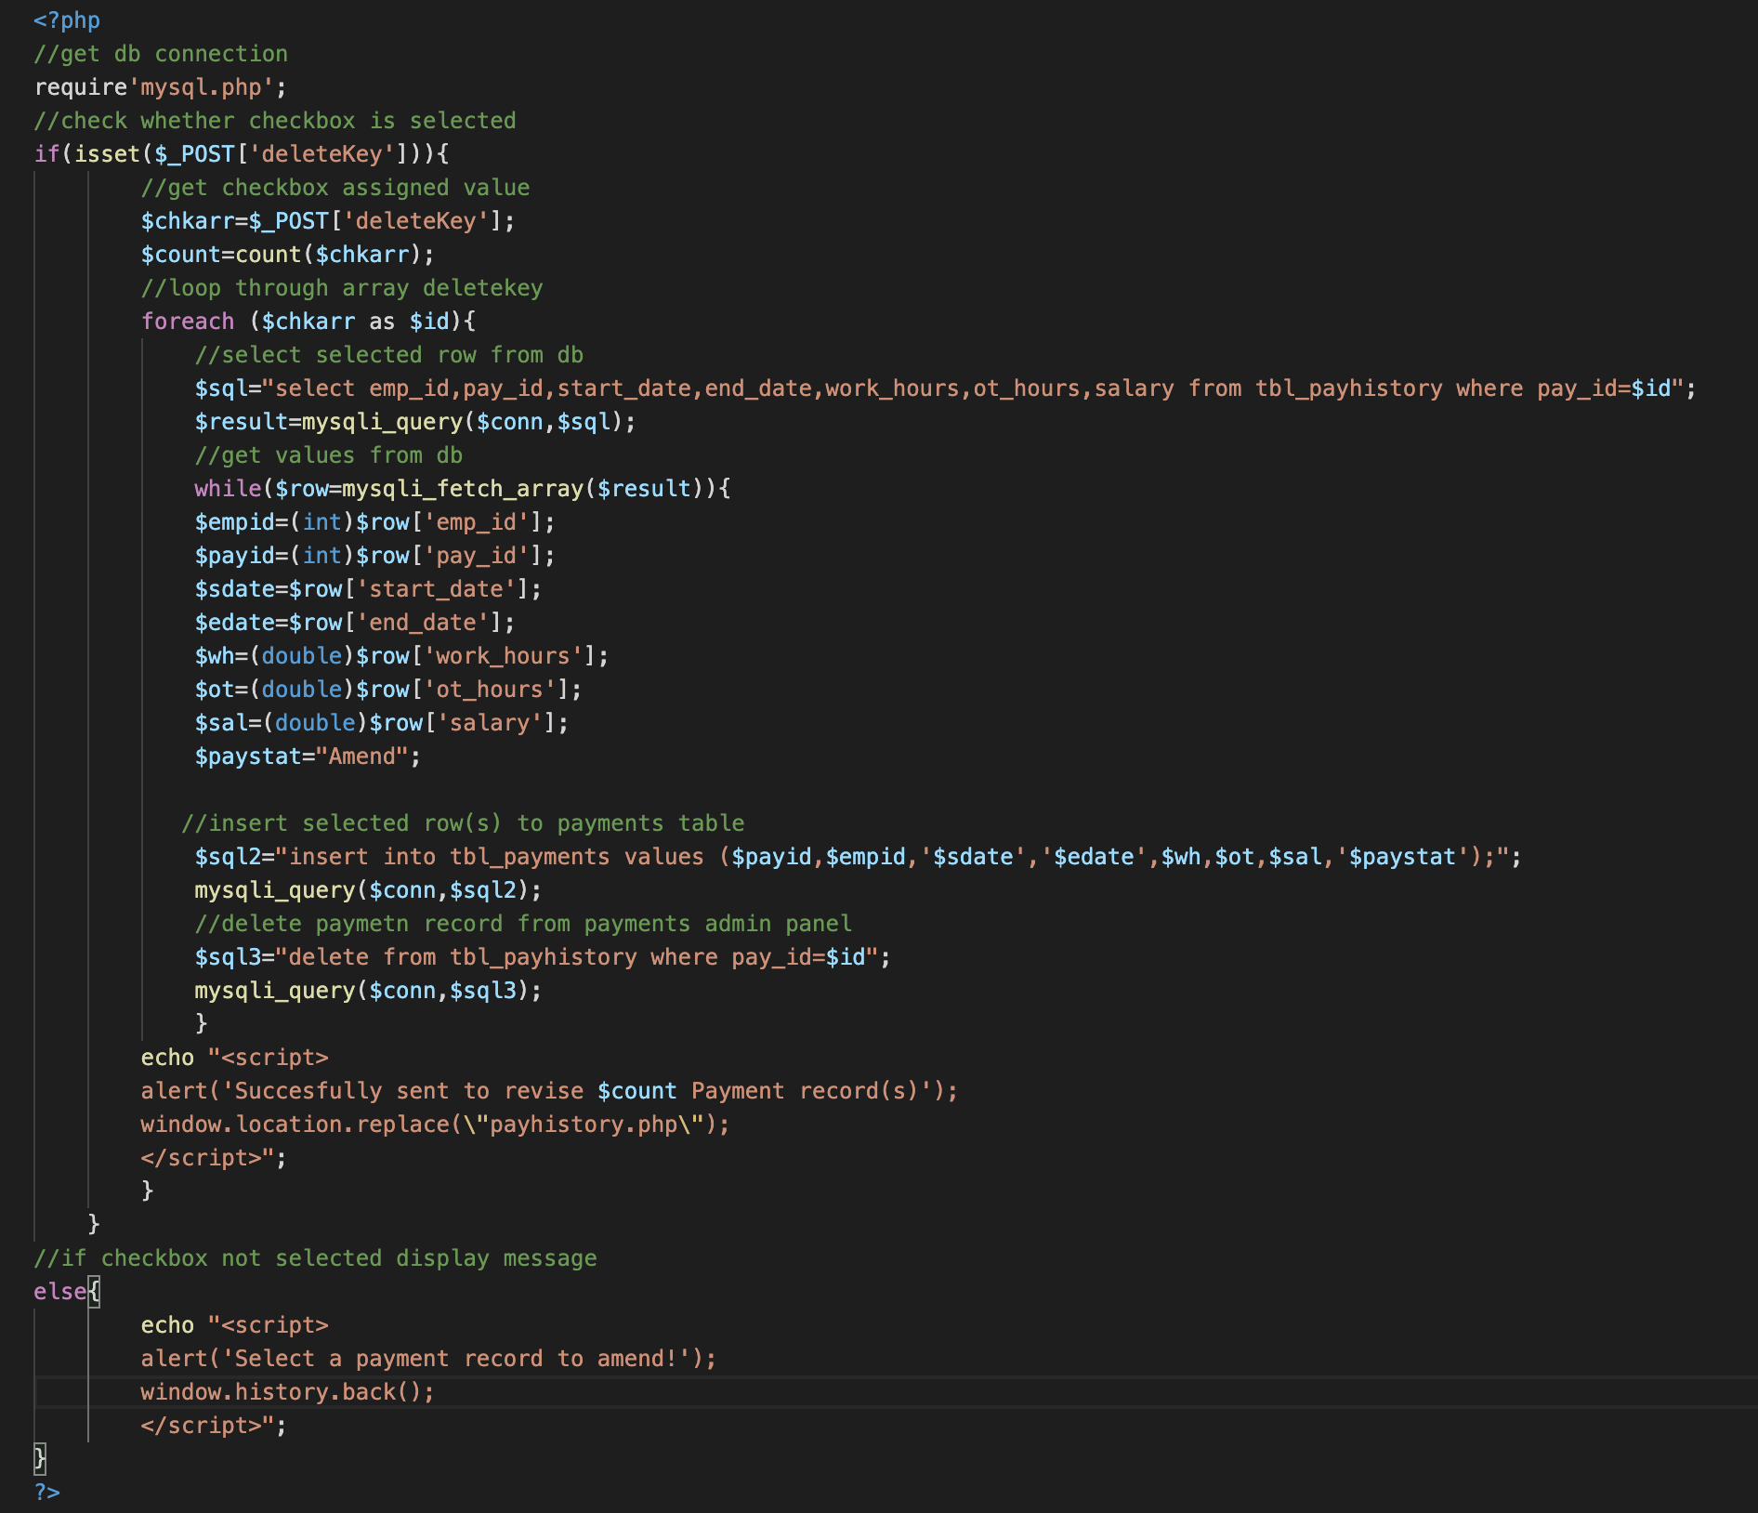

## Employee – Add Employee

On Add Employee button click -> Function -> addEmp.php

## Employee – Edit Employee

On Edit button click -> Function -> updateGET.php

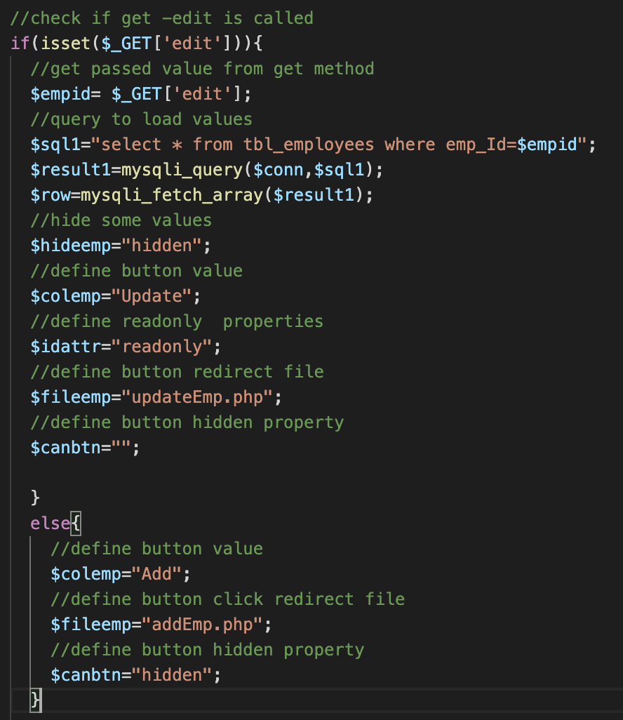

Get method is used to pass employee id as ‘edit’ to server.

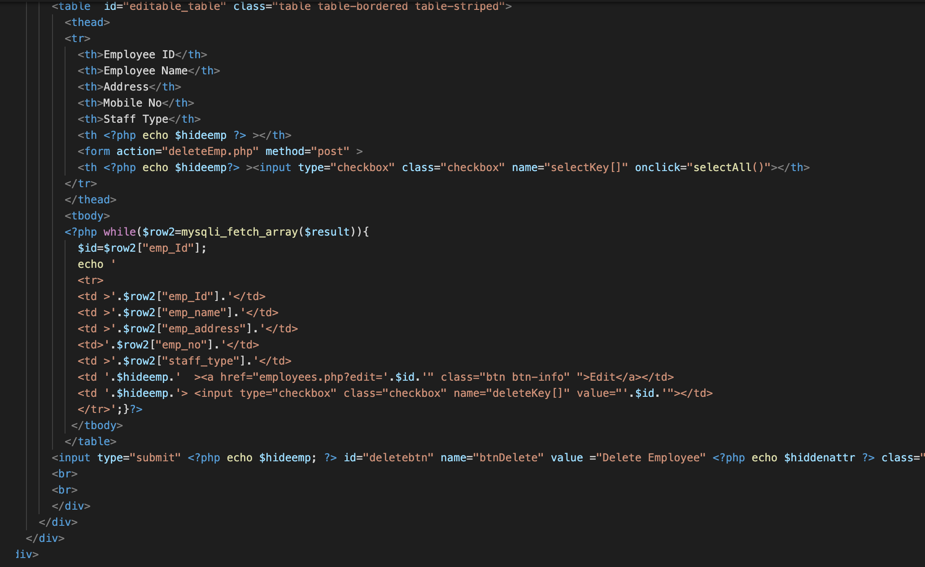

## Employee – Delete Employee

On delete button click -> Function -> deleteEmp.php

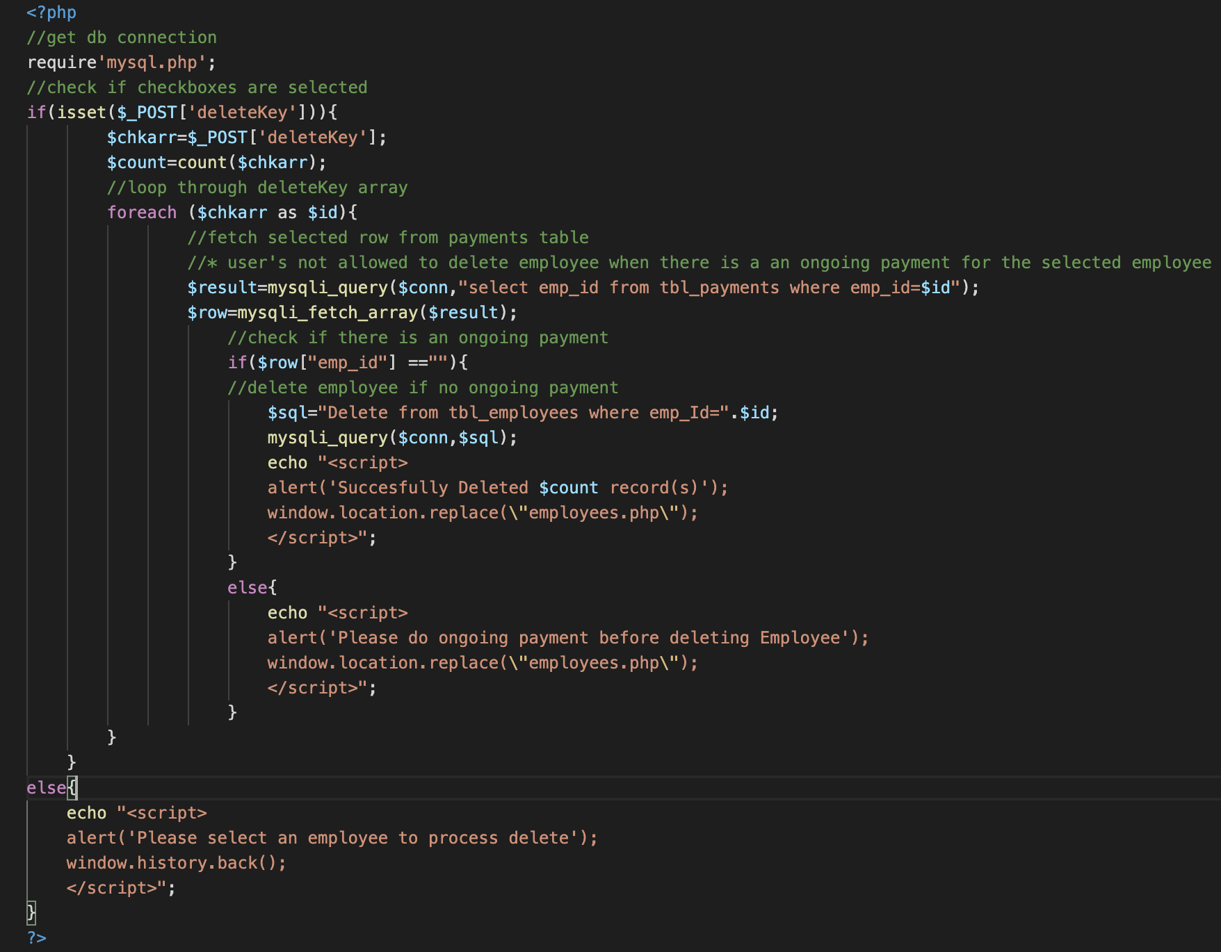

## Settings –> User Accounts - Add User

On Add User button click -> Function -> addUser.php

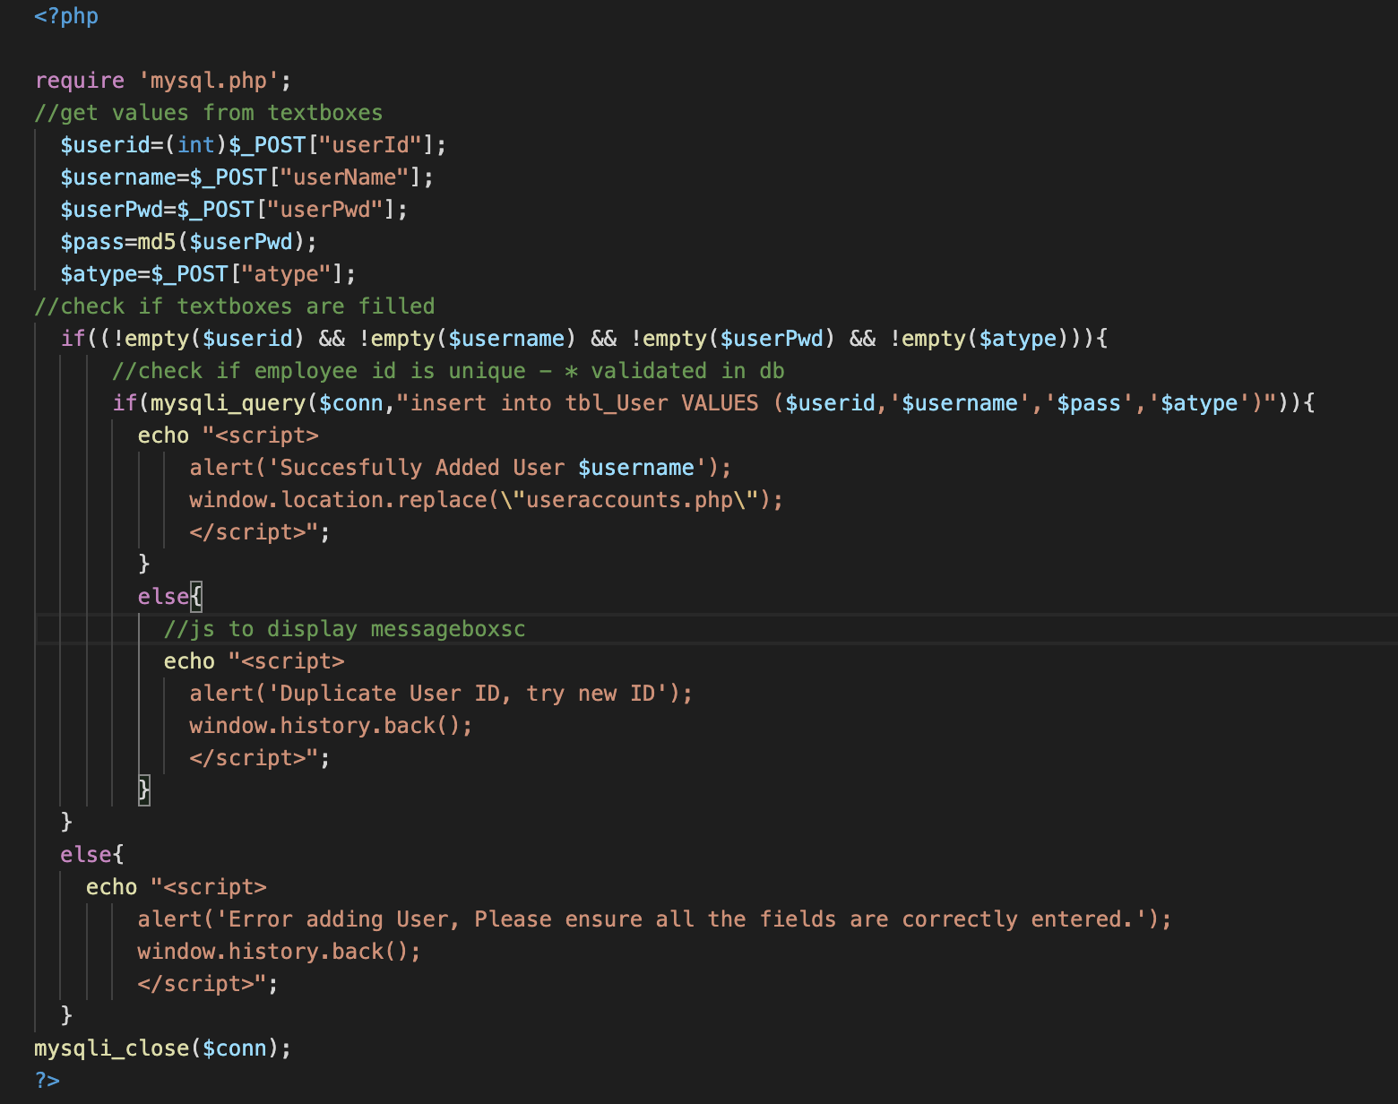

## Settings –> User Accounts - Edit User

On Edit button click -> Function -> updateGET.php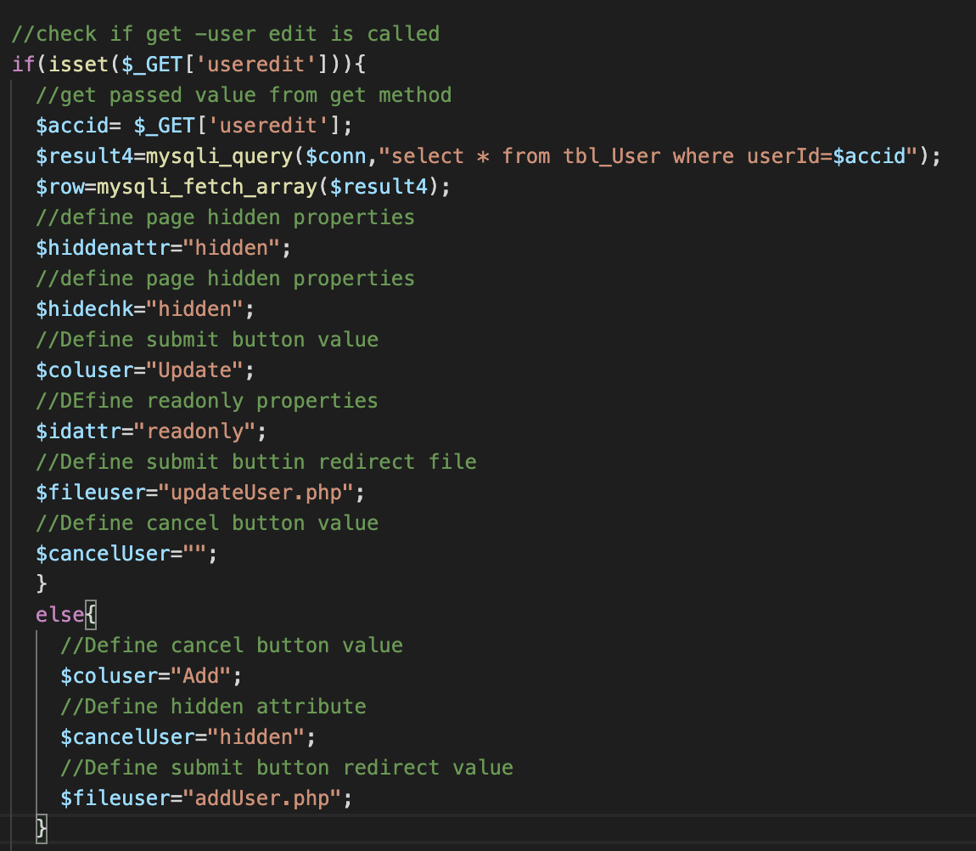

Get method is used to pass user id as ‘useredit’ to server.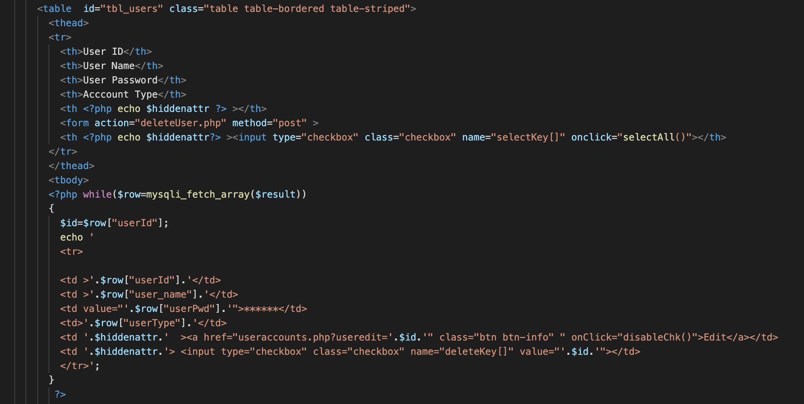

## Settings –> User Accounts - Delete User

On Delete User button click -> Function -> deleteUser.php

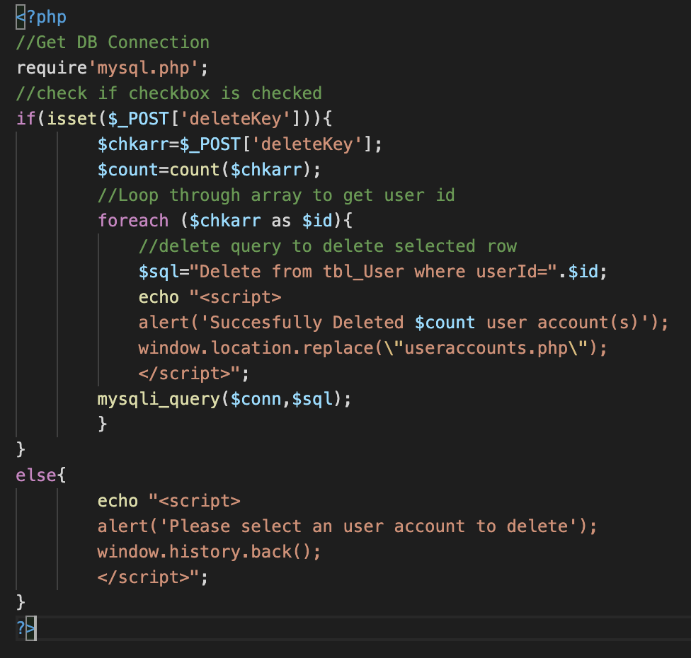

## Settings -> Staff Info & Rates

On Edit button click -> Function -> updateGET.php

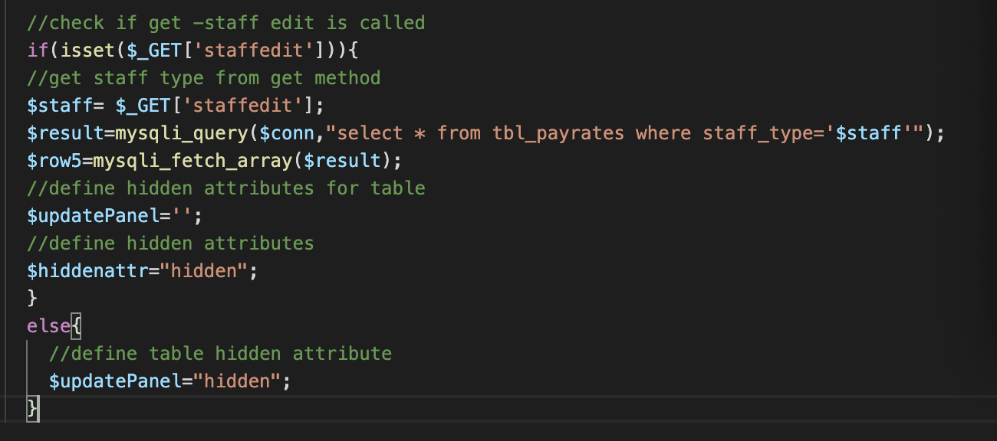

Get method is used to pass staff type as ‘staffedit’ to server.

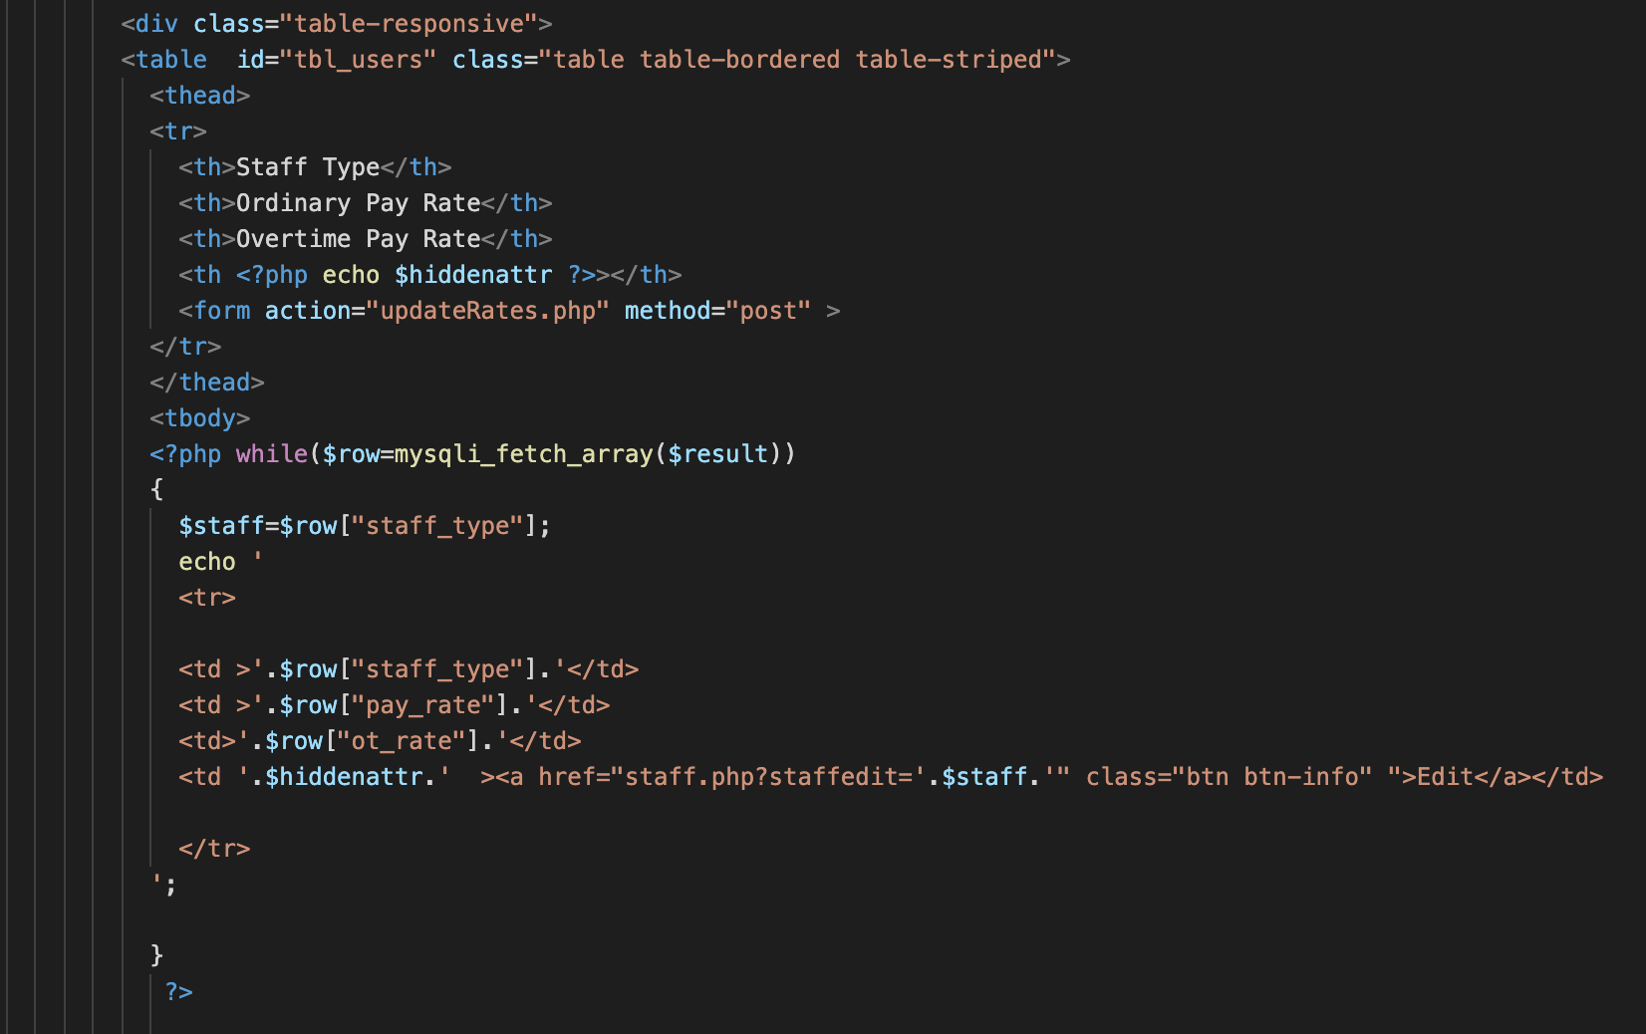

**Validations (formulas.js)**

1. Check start date value is lower than end date.

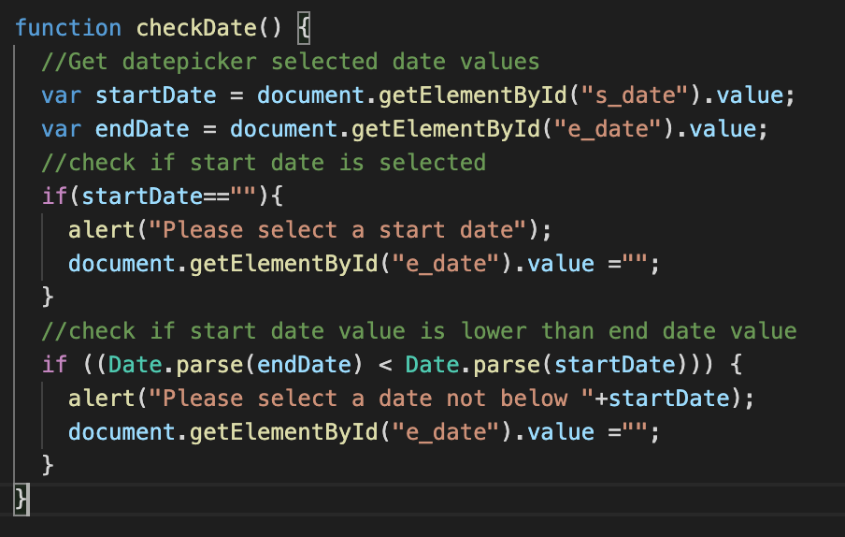

1. Check input value contains only integer & decimal numbers

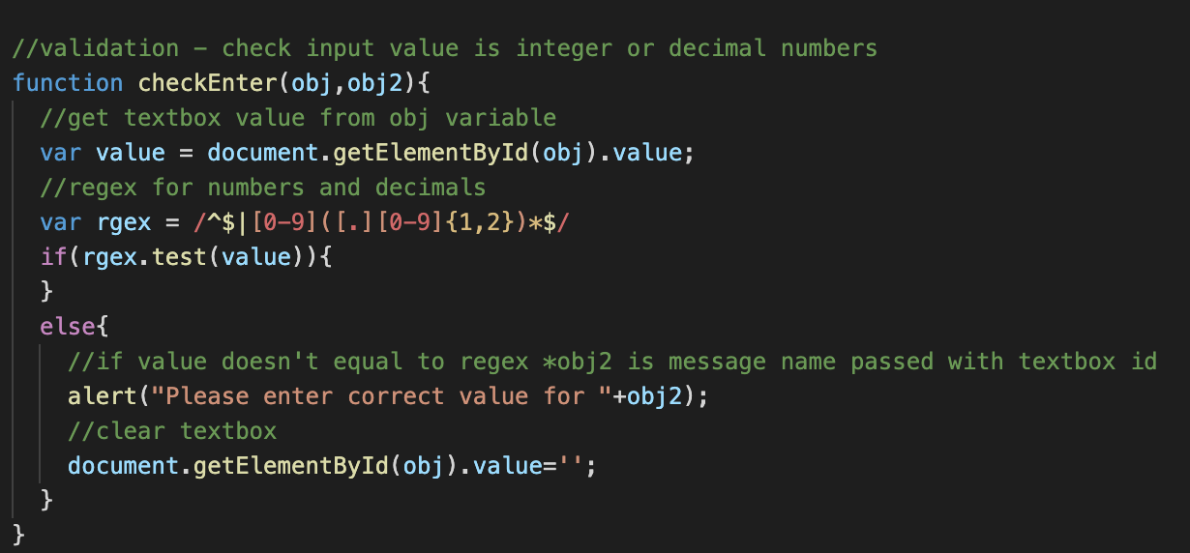

1. Check input value contains only letters and spaces

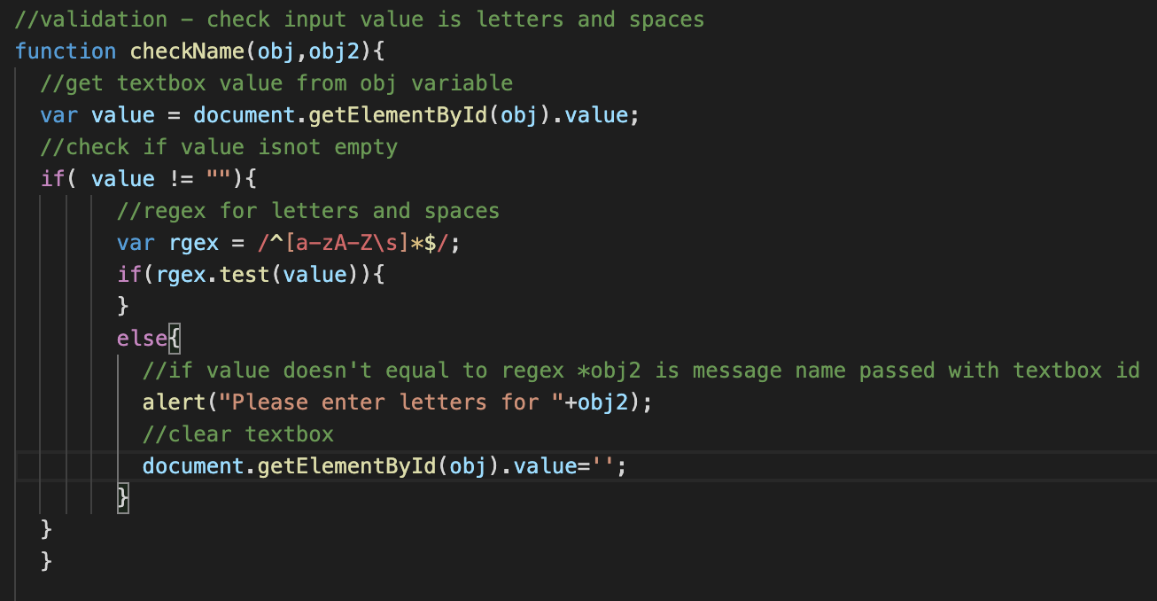

**Cookies**

Cookies are used to save last opened page on each tab (Home/ My Profile / Settings) for easy navigation

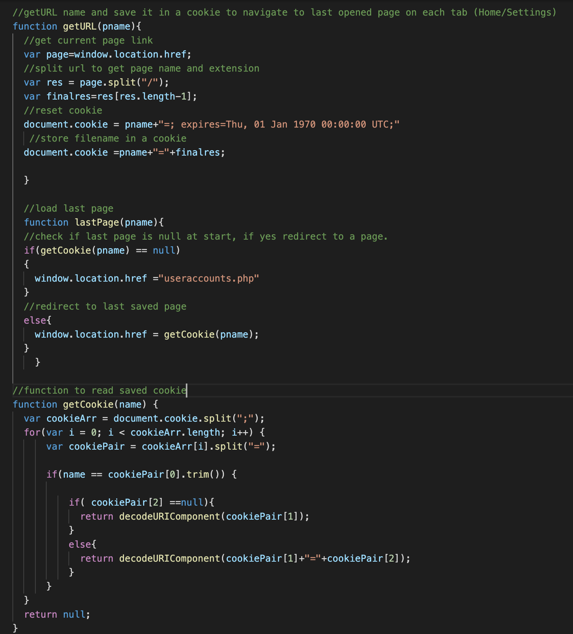

getURL() and LastPage() functions are called in main html pages.

Two cookies are used throughout the app – homeurl, settings

**Main pages-**

* Employees.php
* Payments.php
* Payhistory.php
* Home.php
* Myprofile.php
* Useraccounts.php
* Staff.php

One example is shown below,

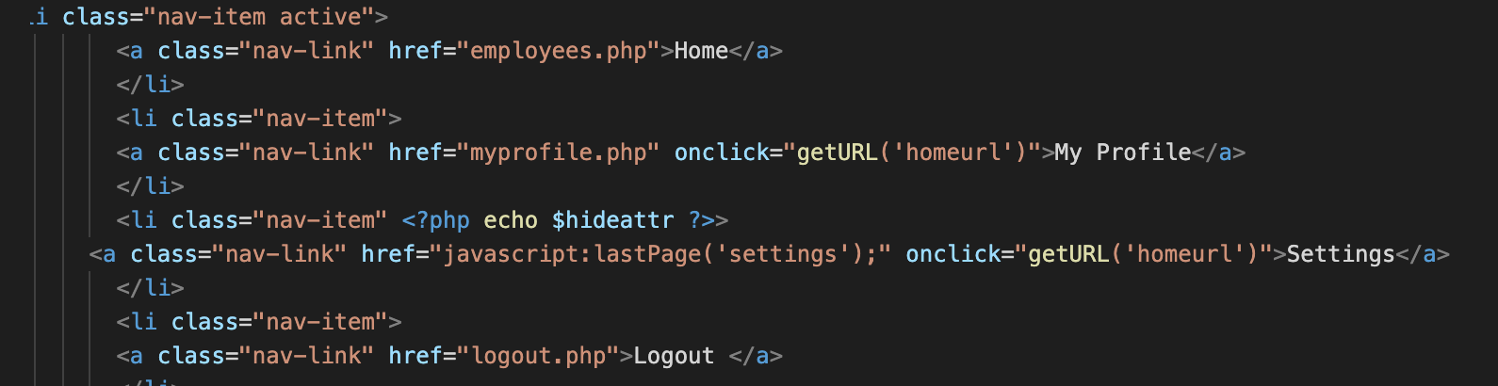

# UML Diagrams

## Use Case Diagram

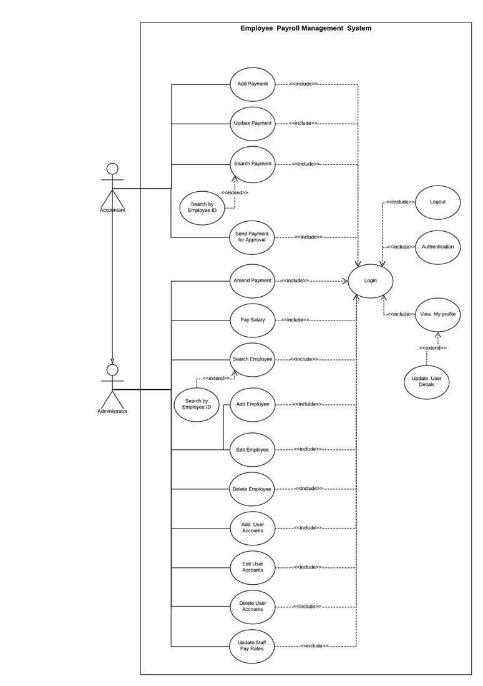

## Activity Diagram

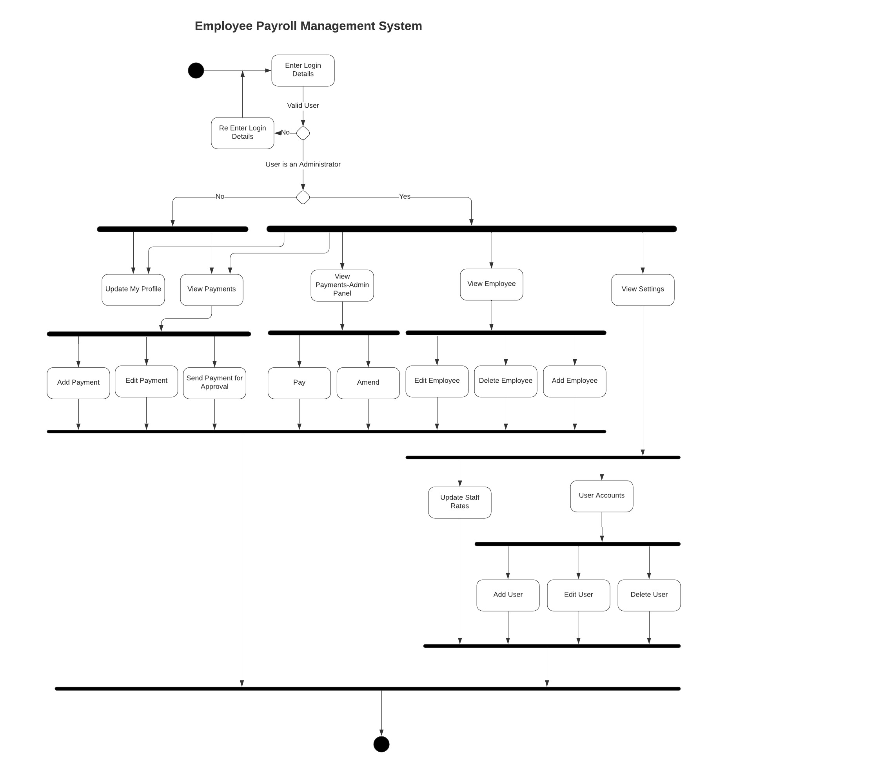

### Database Tables

MYSQL database used throughout the app as a datastore and for input validation. Below figure describes the way data tables are arranged.

Main Tables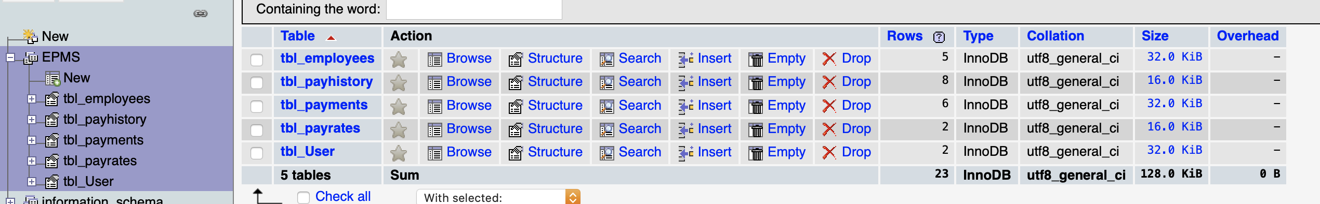

Employees table

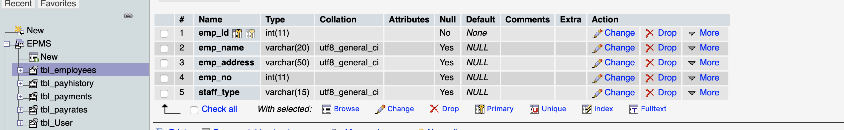

Payments History table

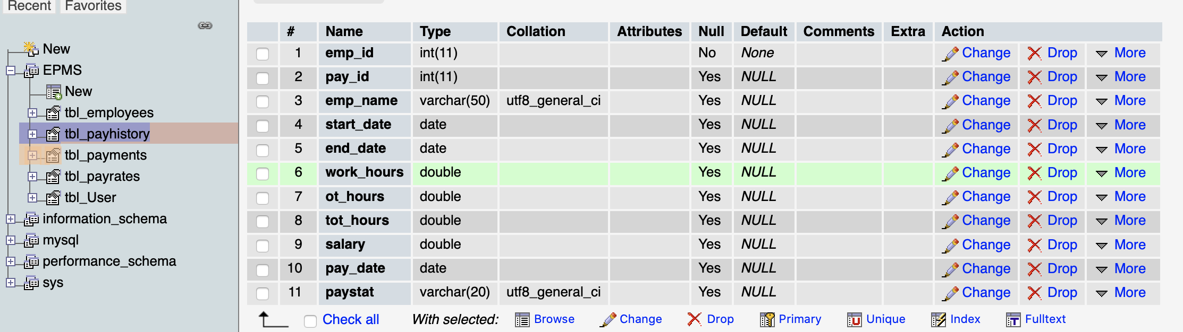

Payments table- *Payment ID is auto generating using auto increment function of Db started from ‘1’

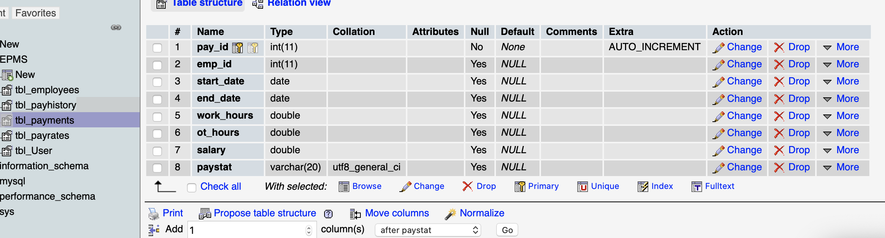

Staff Pay rates table

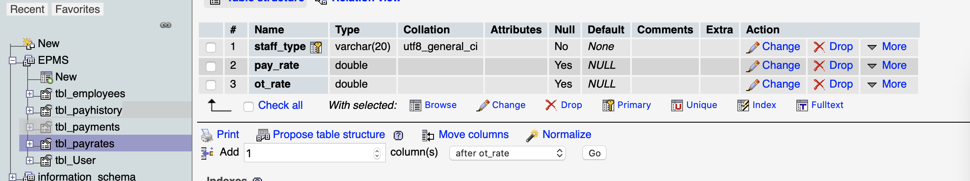

User Accounts table